Student: John Mitchell (Dave) - 20077126

This report has been prepared for Rosanne Birney

Website Design &Development Report –JDM.ie

HCI and Web Design Assignment 2.

Table of Contents

Introduction 2

Wireframes: 3

Desktop Designs 3

Mobile and Tablet Design. 5

Interface Design 7

1. Know the User 7

2. Structure and Layout 7

3. Navigability 7

4. Consistency 7

5. Content 7

6. Text 8

7. Quality of Design 8

8. Colour. 8

9. Messages for the user 8

10 Technology Capabilities 8

Results and Comments. 9

CSS Validation: 9

HTML Validation: 9

Accessibility Tests: 11

Cross browser Testing: 13

Responsiveness 15

Conclusion 15

Appendices 15

Appendix 1: Some suggestions for the future. 15

# Introduction

JDM Ltd, a fictitious start-up Consultancy and Training services operation, has requested that we deliver the design and development of a website. The site is to be the centre piece of their business launch. The users of this site are potential clients and partners.

The company will provide its services in the areas of Business Analysis, Project and Programme Management delivered both on-site and on-line. The site will need to promote JDM Ltd. Services and offer ways to contact them to engage or discuss business opportunities. The company’s business plan anticipates that the clientele will be corporate and public sector providing business solutions either internally or to other organisations.

The site must be as assessable as possible and responsive to users of different devices. Initially the site will consist of four pages. HTML5 and CSS3 will be used in the creating the site. Hosting, final content loading and on-going support will be addressed directly by the client. The output of this project will be the commented HMTL files and CSS files together with this report delivered in a zip file format.

The following content could be available on the site:

* Images and Maps
* Audio Visual
* Tables
* Links
* Forms

The high level plan for the project is as follows:

1. Wireframe Prepared in consultation with client including proposed navigation. Agree standard fonts and colours to be used throughout site.
2. The four pages prepared and tested iteratively.

* Home Page (“Homepage.html”)
* Contact Page (“Contact.html”)
* Consultancy Services (“Consulatancy.html”)
* Training Services (“Training.html”)
* Validate HTML and CSS.

1. Test accessibility and browser compatibility recording outputs.
2. Put page deliverables and report in to Zip file.

.

# Wireframes:

The following are the wireframe mock-ups of how the site should look on completion.

## Desktop Designs

This is how we envisaged the 4 screens should look when created.

**Home Page (**<https://wireframe.cc/W5ohc3> )

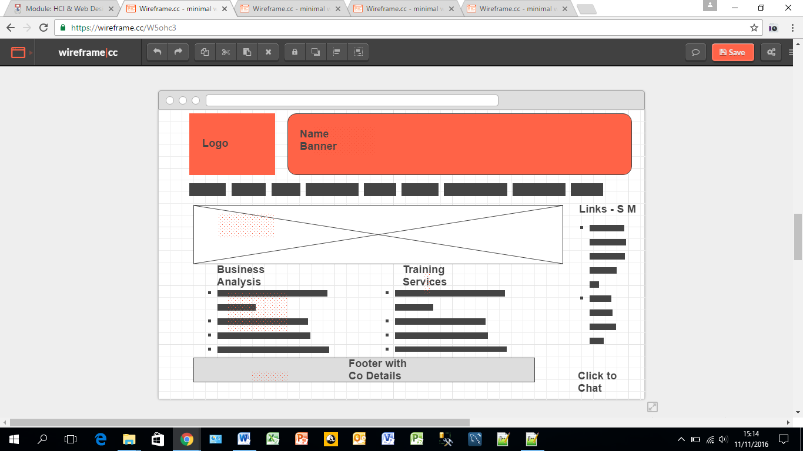

**Consultancy Services Page (**<https://wireframe.cc/tzPxrQ> )

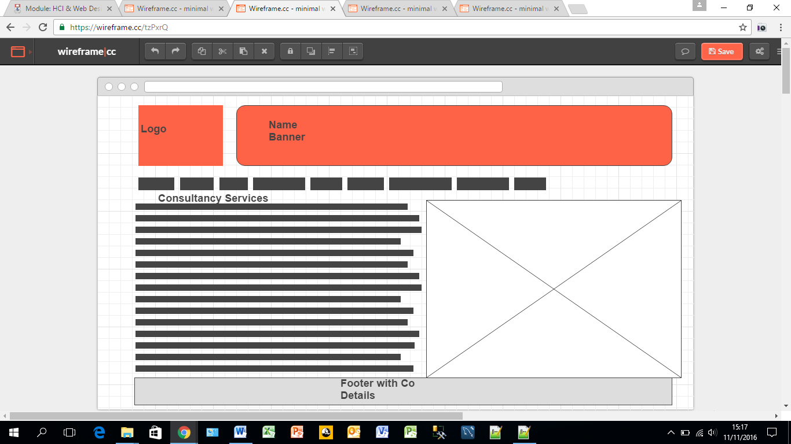

**Training Services Page (**<https://wireframe.cc/GgPMuL>)

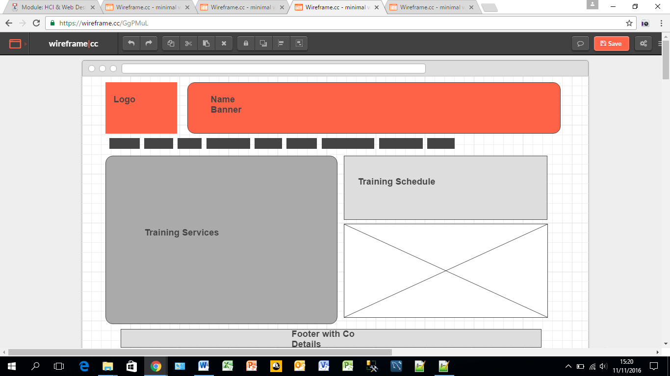

**Contact Page (**<https://wireframe.cc/rwRiFb>)

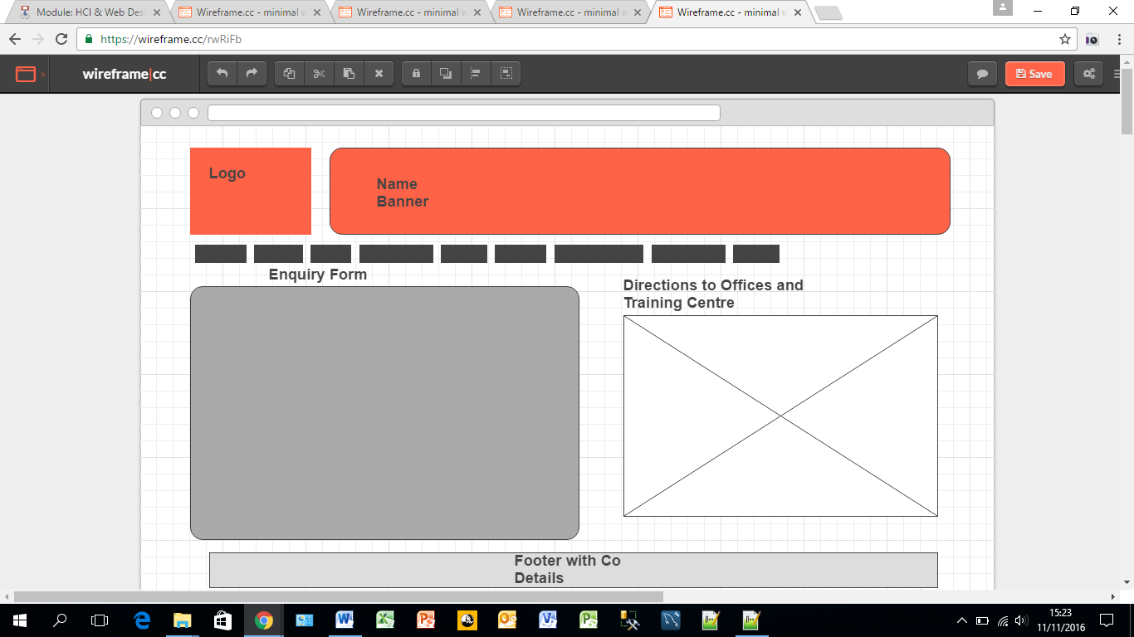

## Mobile and Tablet Designs

This is how the site might look on a responsive solution.

**Home Page** <https://wireframe.cc/sqMunt>

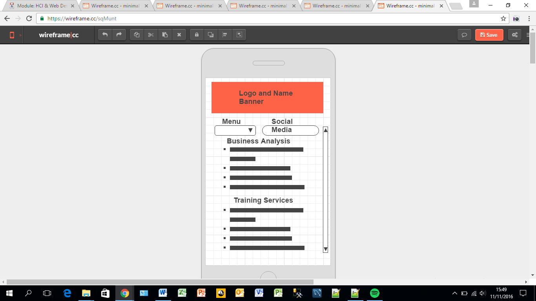

**Consultancy Services Page (**<https://wireframe.cc/e1cVbK> )

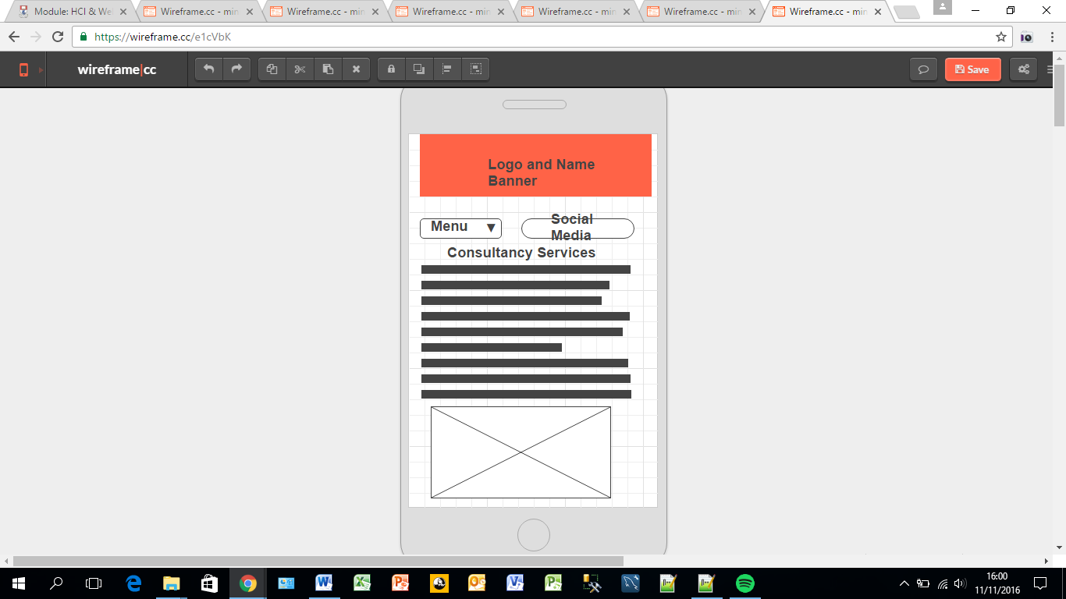

**Training Services Page** <https://wireframe.cc/CPwcWl>

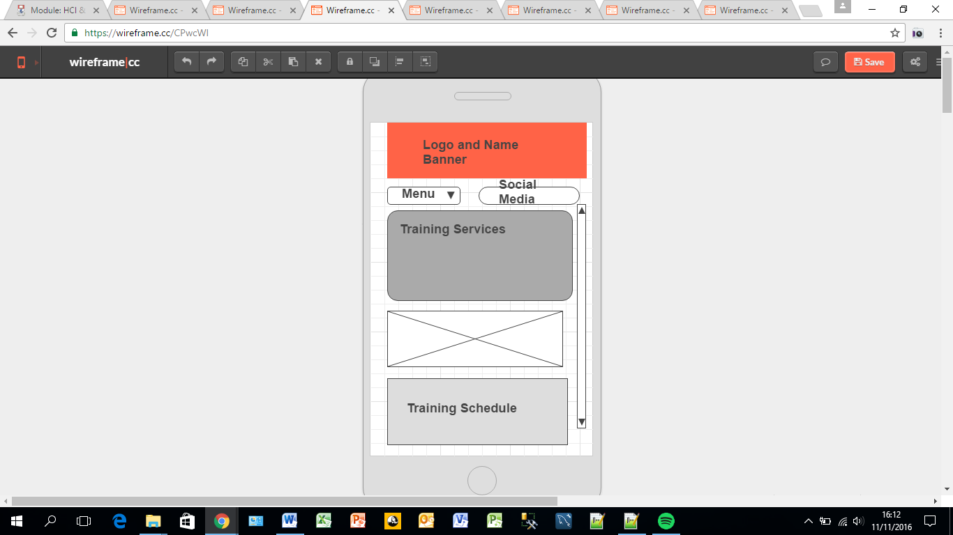

**Contact Page (**<https://wireframe.cc/uIW9c8> )

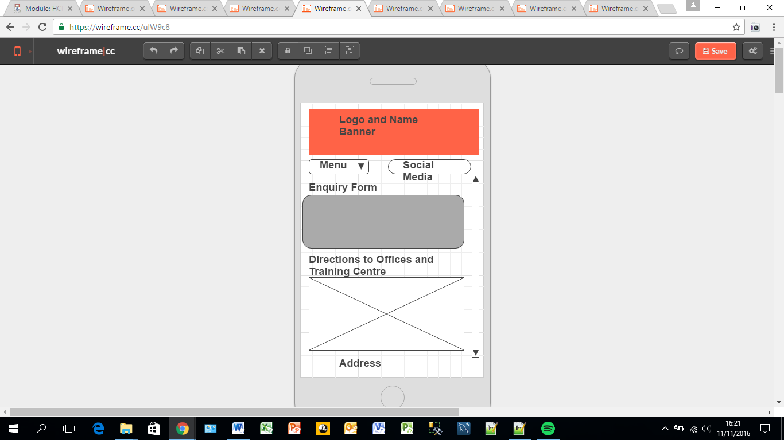

# Interface Design

.

There are 10 Interface design concepts that we should consider for the solution.

## Know the User

Who will use JDM.ie and what would they use it for?

The target audience for this website are software development companies and internal IT department’s responsible for system development and deployment requiring consultancy and training services. Prospective clients may be in the Public or Private sector.

## Structure and Layout

Is the site navigation logical and consistent? Is the data presented in manageable and related chunks?

The menu selection headers and footers are identical on all pages (I did however use <footer> on 2 pages to try it out. The others had been completed before I found out about these HTML5 tags.

I have tried to you F pattern as much as possible. The Data has been organised logically based on the services offered. The pages are not overloaded with content or unnecessary features.

## Navigability

Without proper navigation users will not access the correct or required content.

I believe the site complies with a 3 clicks test. I have also used a consistent link format on the internal links displayed in the content. The Nav section is propagated on all 4 pages.

## Consistency

Is the site maintaining a similar design in terms of colour graphics and fonts?

CSS is enforced across the 4 pages. Standard Headers and colours are used throughout including for backgrounds. Column classes have been reused where possible.

## Content

The adage “Content is King” applies to websites and user will compromise on other deficiencies if the get the data they are looking for.

Users tend to scan web pages in an F shaped pattern rather than read a page when it opens.

Although this site is fictitious I have created content that I would expect to see or display if it was my own business. The services are logically divided and presented. There are links with in the site to important functions like the contact form.

## Text

The reserved words that I have tried to use across the site are “Consultancy Services” and “Training Services” mainly.

Fonts and text sizes are constant across site and enforced by CSS. The site is WC3 CSS compliant. I believe that the presentation of the text is clear and concise.

## Quality of Design

Is the design simple making the content easy to absorb?

As this is my first attempt at web design I have kept the design as simple as possible and avoided cluttering pages or overusing features like images and links.

The graphics and backgrounds are used to draw the users attention to the company offering. I have used images of people’s faces as this has proven to be an excellent way to draw people’s attention on a website.

## Colour.

It is consistent due to the use of the style sheet. Simple Predominant Background colours used (#efefef and #665544) and plain Red and Black used in headers.

No problems were highlighted by the accessibility checker on any of the pages. Although Red is an issue for colour blindness by framing it in black it is still readable.

1. Messages for the user

I have tried to present a simple clear and consistent impression of JDM Ltd without overloading it and confusing the basic message that it provides Training and Consultancy in the areas of Business Systems Analysis and Project and Programme Management.

.

## Technology Capabilities

There are 3 questions we need to answer relating to finding and making use of this site.

1. *Bandwidth:* No issues as I have limited the number of HD images etc. that might slow the site from loading.
2. *Performance across platforms*. It has been tested on Chrome, Edge and Firefox browsers successfully. It is not fully responsive – this is addressed below.
3. *Searchable?* Different description tags have been added to each page.

.

# Testing and Results.

## CSS Validation:

Using the official CSS 3 validator ( <http://jigsaw.w3.org/css-validator/validator> ) the site has passed with no error. The site could therefore display the compliance icon:

Valid CSS!

A screen shot of the results is below:

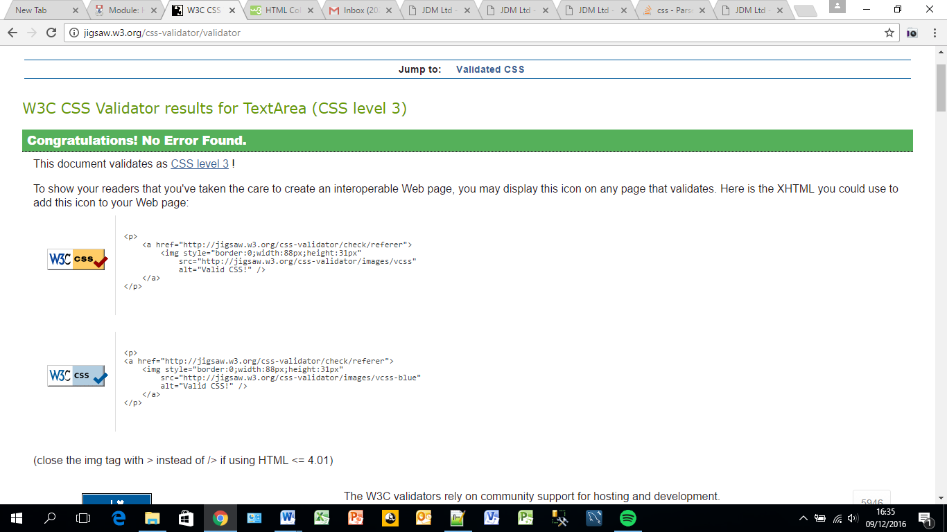

## HTML Validation:

No errors were on the Home page see screenshot below:

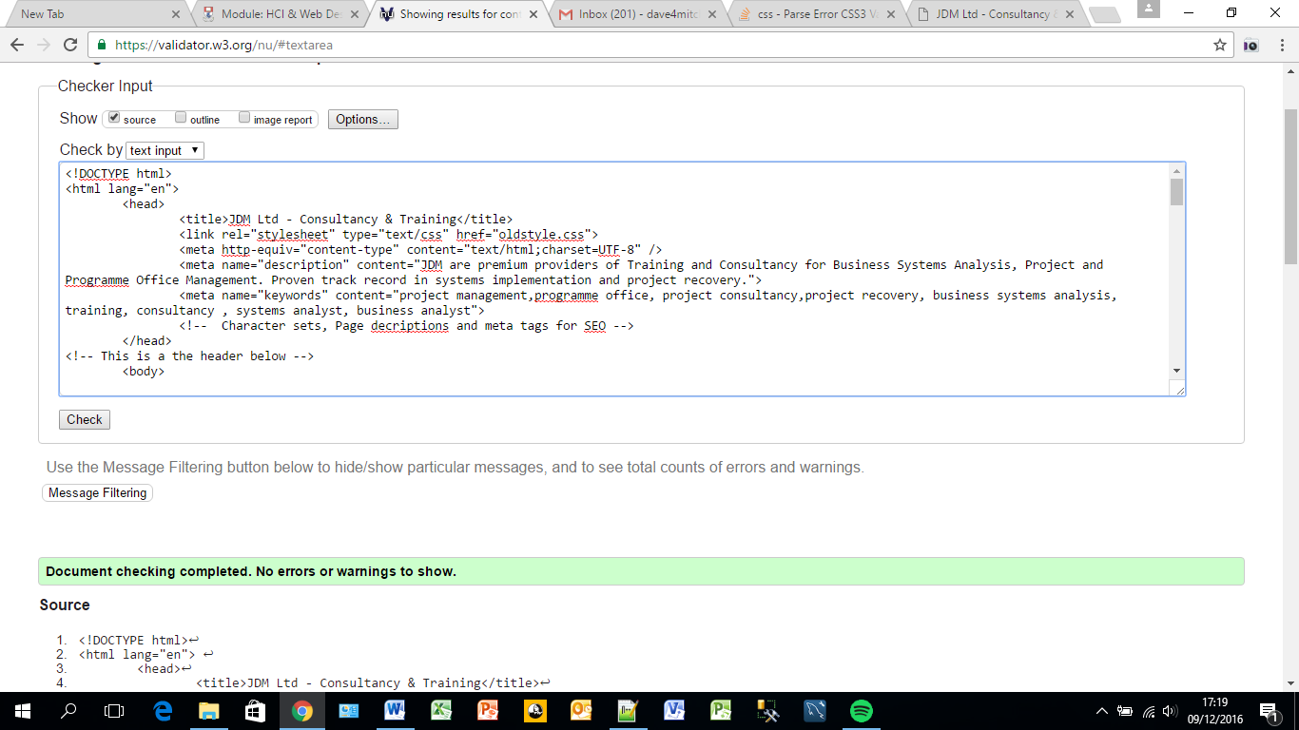

There were 3 errors on the Consultancy page. These relate to the mixing of unordered list items and ordered list items in the left hand Column. This will need to be fixed in the next iteration. It will not hinder the operation of the site at this point in time. Screenshot of the errors below:

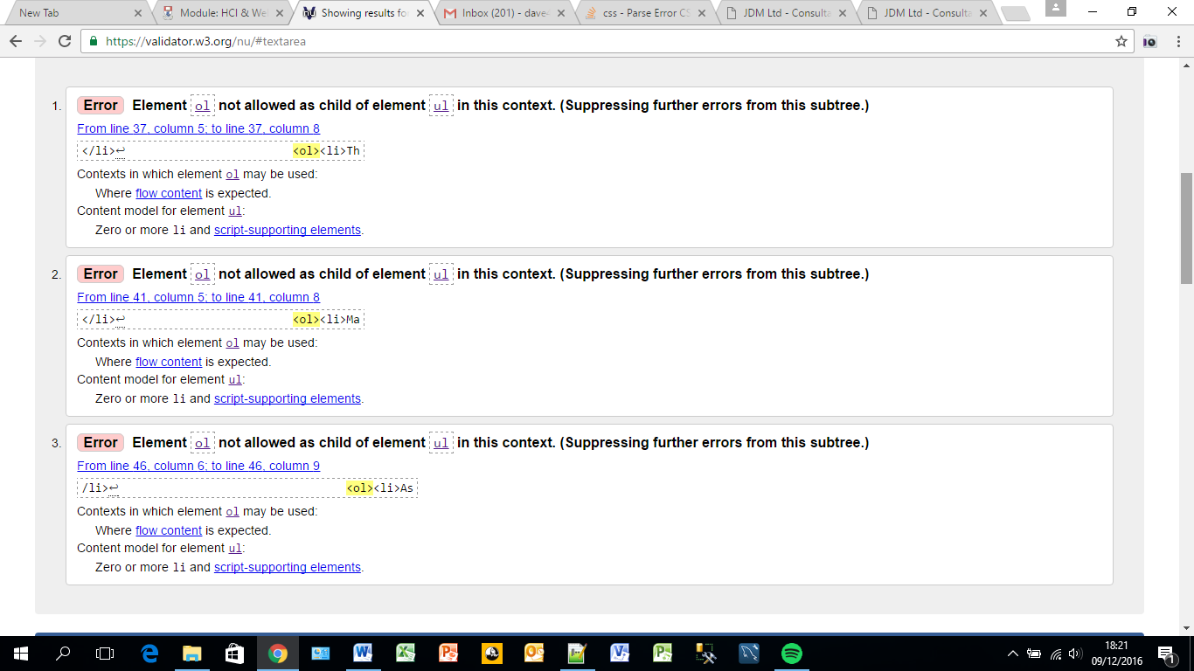

There are 5 HTML errors on the all related to the nesting of paragraphs in lists – similar to the previous page. Again these should be fixed in the next iteration. A screenshot of the errors follows below.

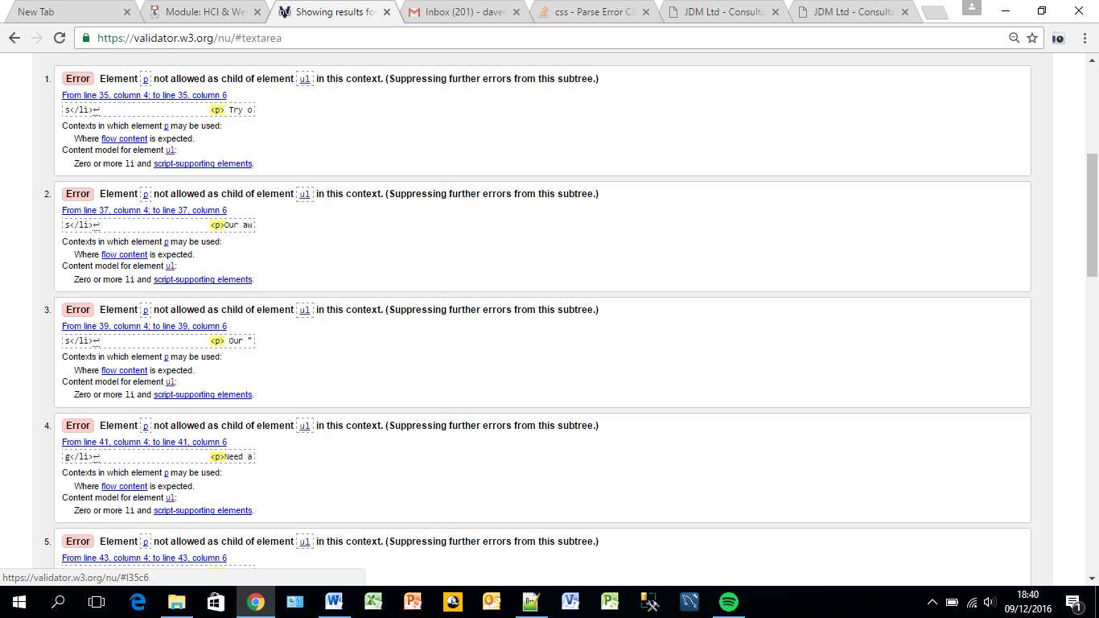

The Final page – Contact.html – also has 5 errors. A screenshot is again shown below.

There are issues with the labels in the form. These need to be corrected like the others in the next iteration.

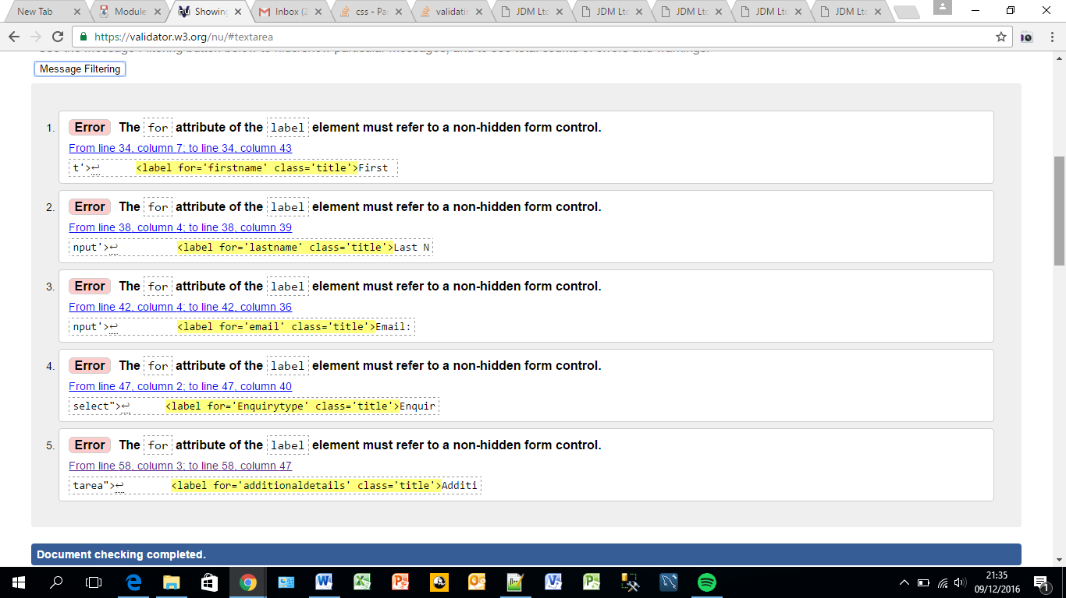

## Accessibility Tests:

By applying an automated accessibility test - <http://achecker.ca/checker/index.php> - we get a report indicating conformance with Web Content Accessibility Guidelines.

The Homepage conforms to the WCAG 2.0 guidelines in terms of known problems.

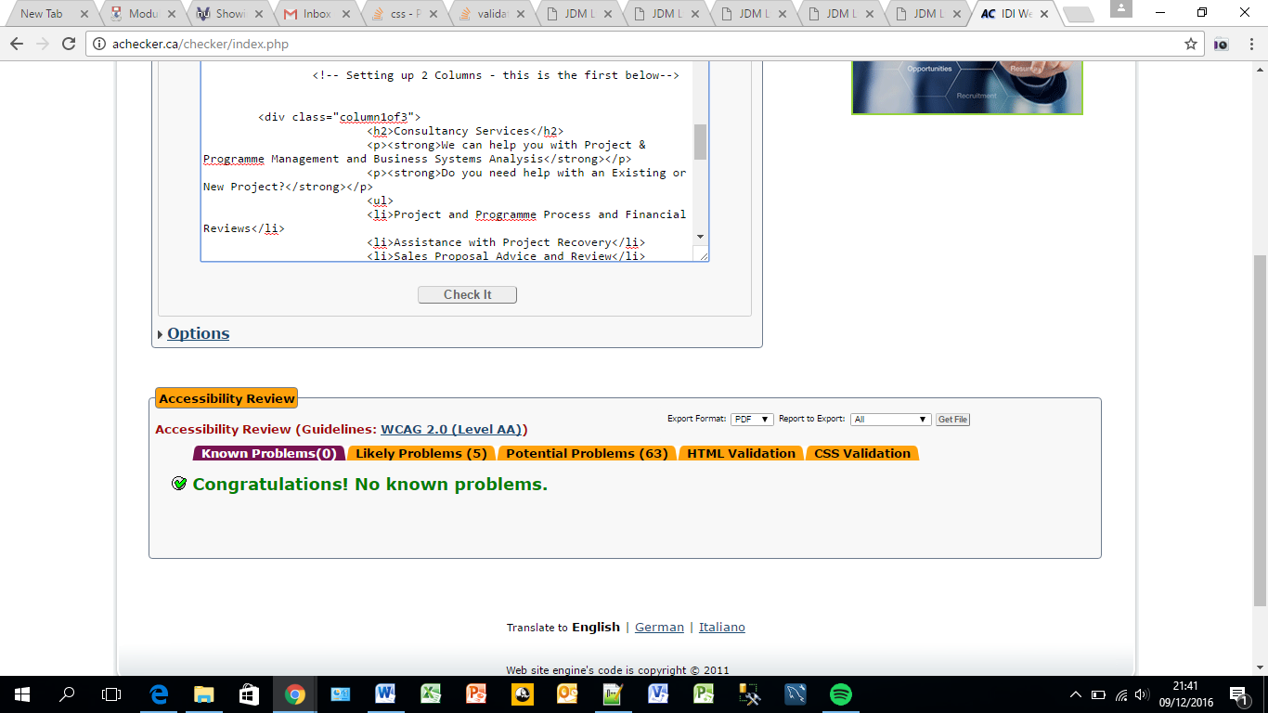

The Consultancy.html page is also compliant.

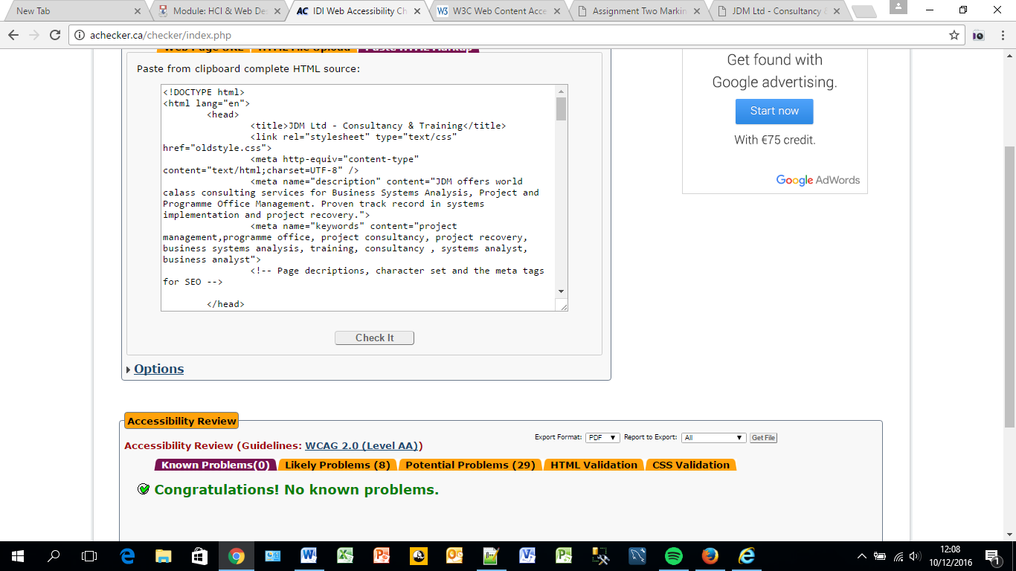

There were 2 errors on the Training.html pages related to the labelling of columns and rows where scope was not used (e.g.<th scope="row">). This should be resolved in the next iteration.

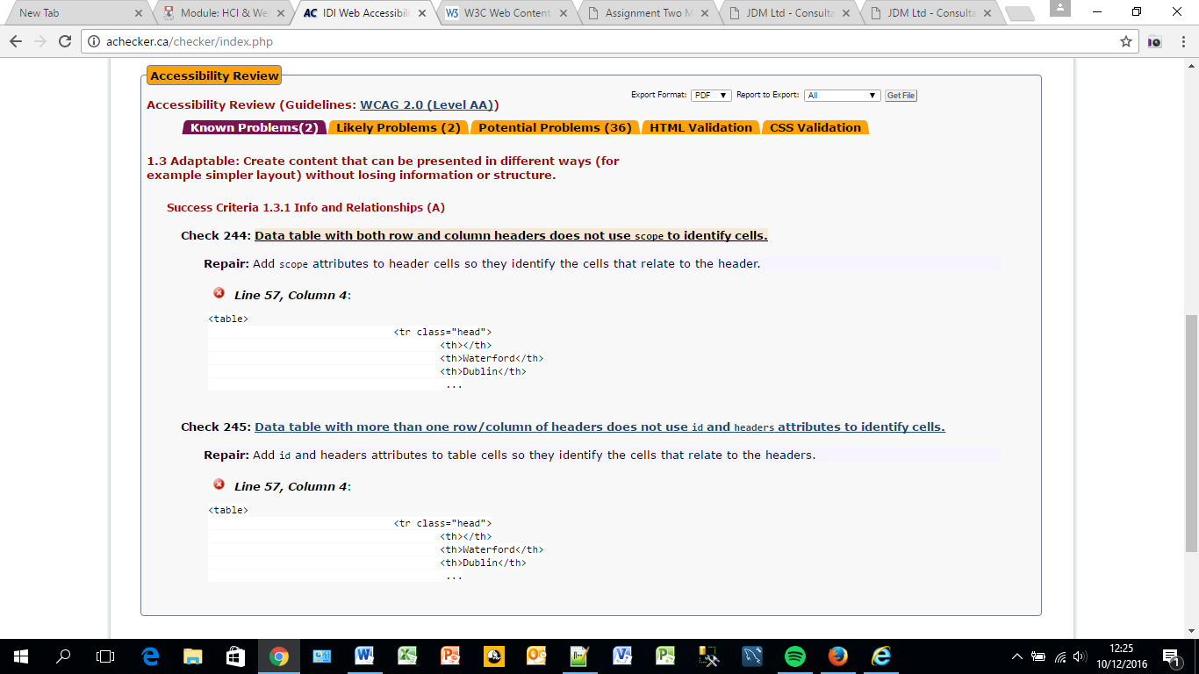

There are 9 problems on the contact page – these again relate to labeling this time in the Contact Form.

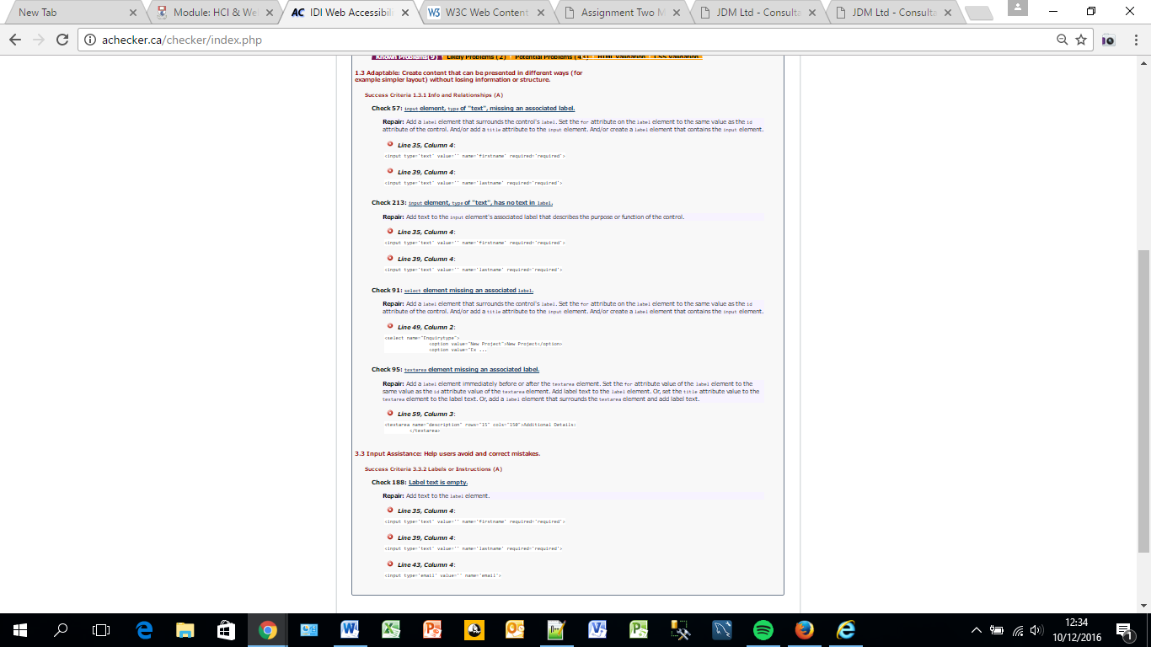

In summary 11 issues were detected indicating it fails AA compliance – if these issues were resolved in the next iteration it would be possible to display the compliance icon.

## Cross browser Testing:

1. Chrome

There are no issues using the 4 pages on Chrome: See example below

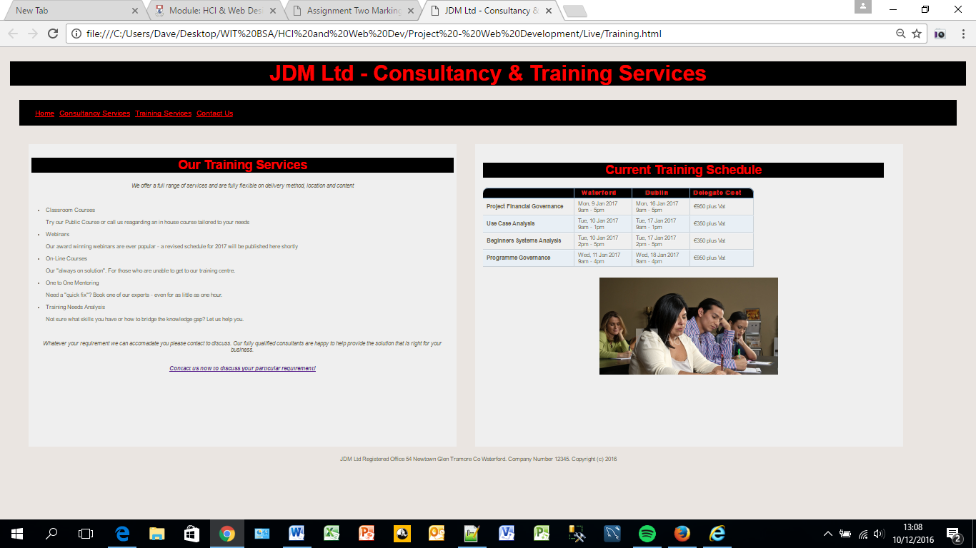

1. Firefox

Apart from this minor issue with content overflowing on the Consulancy.html page (screen shot below). This would need to be fixed prior to go live given the importance of Firefox.

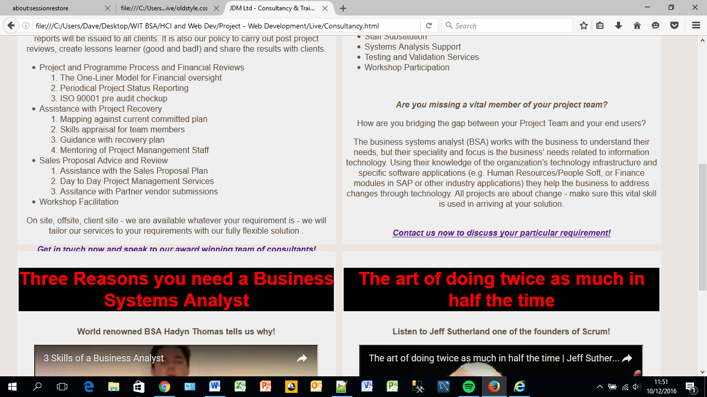

1. Edge

There were no issues on any of the pages – see example screenshot below:

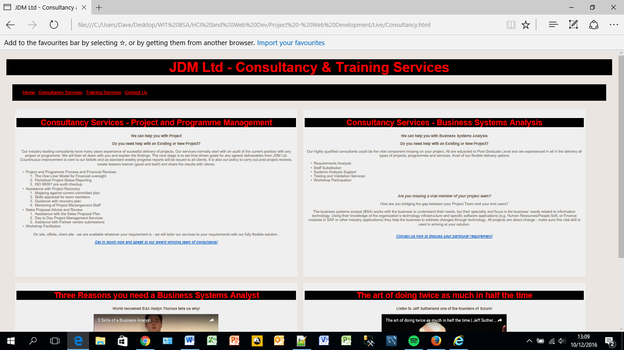

# Responsiveness

Website Responsiveness relates to how the content is resized or repositioned when a user views it using different screen sizes. Although these pages are not fully responsive relative sizing was used where possible (e.g. em and % used in CSS). This should hasten any enhancement work to make the site responsive.

# Conclusion

The wireframes did provide the basic framework from which I created the site. There were parts that evolved in the course of the development where enhancements where gained requiring changes to the original vision. An example of this was on the Training page where the image was dropped below the schedule table – it gave a better F pattern to the page and was visually clearer. The overall solution is however in line with the original vision.

# Appendices

## Appendix 1: Some suggestions for the future.

Based on the lessons I have learned from this assignment the following need to be considered for the next iteration.

* Add Breadcrumbs to the site to enhance navigability.
* Improve the responsiveness.
* Add relevant Case studies to enrich the content.
* Create and implement a content management plan to keep the site up to data. This should either include or run in parallel with the Social Media update plan. The addition of a blog should also be considered.
* The accessibility issue related to the labels need remedial action.
* Privacy statements and cookie policy etc. need to be implemented on any live version.
* The Images need to be licenced. I have just used Adobe stock as can be seen from the watermark.